Warrant Officer Products for Sale
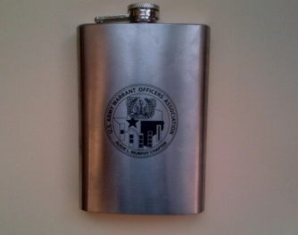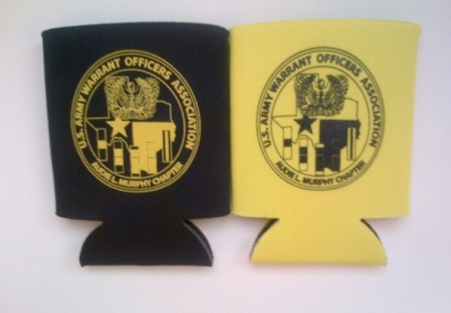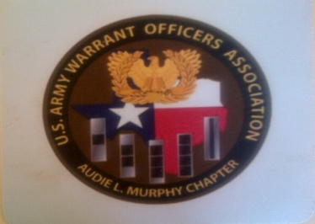
Flask Koozies Mouse Pad
$15.00 $1.00 $5.00

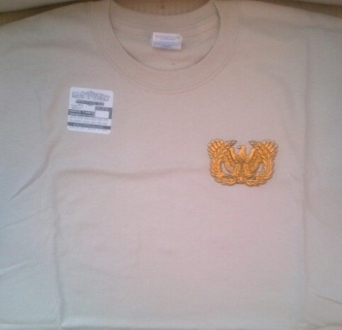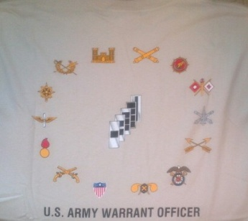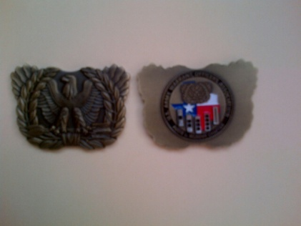
Warrant T-Shirt (Back) T-Shirt Warrant Officer Coin
$10.00(Front) $10.00
Sizes: Med/XL Only

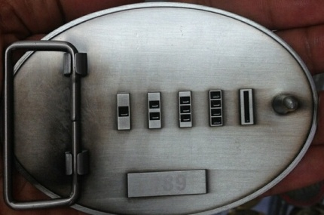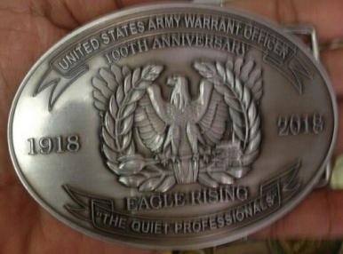

Belt Buckle
$50.00

PLEASE CONTACT CW3 MICHAEL LONG OR CW2 DEVAN LOVE TO ORDER:

CW3 LONG CW2 LOVE
BLDG 15, CAMP MABRY BLDG 15, CAMP MABRY
(512) 782-5547 (512) 782-5254
MICHAEL.W.LONG.MIL@MAIL.MIL DEVANE.R.LOVE.MIL@MAIL.MIL

